The SCOOP
July 2007 Vol. 21, No. 7
The newsletter for the Knoxville Area Model Railroad Club, Inc.
Editor: Jim Schall, phone - 423 369-2955, email - Schallj@highland.net
Website : knoxmodelrailroaders.com

Conductor’s Comments - Larry Burkholder, President
Our regular 1st Sunday meeting will be on July 1st starting as usual any time in the afternoon you feel like getting there. There will be no business meeting.

The museum has decided it can't staff Sundays in the summer, so we will have to hold our open house meeting on the 3rd Saturday in July and August. This month's date is the 21st. The museum opens at 11 am and closes at 4:30 pm, so set your schedule to be at the museum by 10:45 am. With a longer day, the Coordinators may have to schedule members to cover different periods if there aren't enough to cover the whole day. Bring a lunch.

July has a fifth Sunday, the 29th. We will not have a formal swap meet, but we can have a meeting day and if you have something to swap/sell bring it in.

Also in July is our Model Railroading summer camp running every day the week of July 23rd. Each session will be from 9 am to 12:00 noon. A number of you have agreed to join me in helping, so please mark your schedule and be at the museum around 8:45 am each morning you can make it. We expect to have about 15 kids ages 8 to 12. The manufacturer Atlas is supplying most of the materials. I will prepare the T-TRAK module pieces. If you have a MR work kit please bring it with you. We can still use helpers.

Enjoy the 4th!

HO Division – Alex Cameron
Here are the dates for July: Regular club Sunday meeting on July 1, starting about 1:30. It will be Saturday July 21. Thursday work sessions will be on July 5, 12, 19, 26, starting at 9:30. Saturday work sessions on July 7, and/or 14 or 21, starting at 9:30. Work continued slowly with the usual 5 or 6 regular attending members. Many of the missing drops have been added to the yard.
We had a good run session on the third Sunday, with few operating problems. Work progresses on scenery in the mine area, and on the engine terminal.
We pulled up the Homosote in the narrow gauge crossing area, and replaced it with a new solid piece. The old section was several strips of Homosote that had had spacers added for super elevation. The new section is much better, with the newly rediscovered problem of differing tie thicknesses from different track manufacturers. We knew that and forgot, so some shims need to be added to the crossings
Remember that the third Sunday (which will be on Saturday this month) is a run day, so come and run trains. Or not. Just come and see what has been happening
N-Scale Activities - Bruce McElhoe, N Coordinator - hmcelhoe@aol.com
It’s now officially summer and it finally rained in Kingston. ☺ At our last gathering Charlie Womac brought in a new building kit. It’s the Walthers lumber mill that he would like to have placed on the layout. After some high level discussions the consensus is that we just add another section to the layout. The following drawings depict the proposed extension to the peninsula’s return loop module. Keep in mind that this is just a proposal at this time. The drawing shows the mill located on the main level within the loops. The high track coming off Phil Brooks module will swing out onto a side extension, then curve back onto the semi-circular end extension piece. The two existing loops will now be partially covered by a tree-covered ridge. The ‘logging’ trackage will curve around the ridge into a valley where the real work of logging will take place. This concept visually gives a separate logging scene that a view from the visitor’s side will be looking up into the valley.
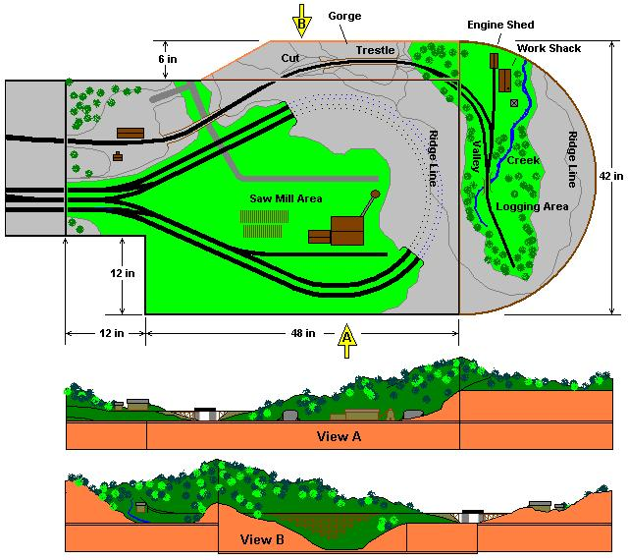
Large Scale Rails - Jim Schall
We continue with our Wednesday evening gatherings and we seem to have gotten back into the modeling mode! A couple of us are back at the layout working on scenery while others are bring in pet projects to work on or for “show and tell”.

Ken Parrson stopped at Die Cast Direct, in Frankfort, KY, on one of his trips to Indiana and brought us all some very nice die-cast pick trucks that have not made it to the Walmart shelves and probably won’t because they are a relatively new manufacturer in 1/64 scale (Yat Ming has been making 1/18 scale vehicles for some time.) A couple of unusual ones at that, a ’36 Ford, ’38 Mack (yes they built pick ups until WW2), and a nifty ’39 Studebacker. And he continues to bring in interesting projects that he is in the midst of creating.
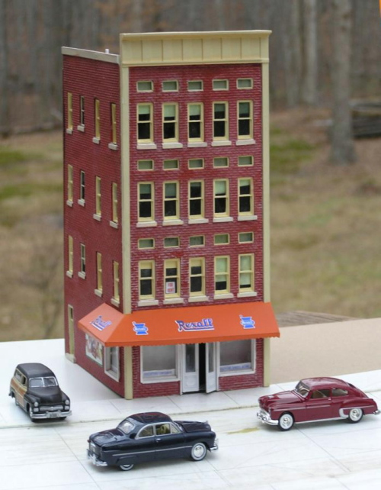
I have been building models for a couple of guys and have brought in a couple of projects in as well. I am currently putting together a batch resin cast building in s scale that are “up scale” Design Preservation Model like kits which have been fun --- especially since a couple of the kits are dupes, so I get to go out of my way to make them different.

One of the buildings that I am doing for a city scene that a fellow is going to be putting together. (These are some of the 1/64 die cast autos that turn up occasionally, they really are nice models for around $4 a piece.

Activities Calendar
In an effort to get more of us to use our web site the calendar has been moved to knoxmodelrailroaders.com. This should get more of us to the site and hopefully to participate in the exchange of ideas and info that is found there.

