The SCOOP
September 2010 Vol. 24, No. 9
The newsletter for the Knoxville Area Model Railroad Club, Inc.
Editor: Jim Schall, phone - 423 369-2955, email - Schallj@highland.net
Website : knoxmodelrailroaders.com

New to website
Minutes to KAMR business meeting will be added to the club website.
Since we do not have business meetings monthly, the minutes will appear
as a separate folder on our site.

Conductor’s Comments - Larry Burkholder, President
Our regular 1st Sunday gathering starting about 12:30 pm will be the 5th. There will be a short business meeting starting at 4:15 pm. Our regular 3rd Sunday Open House will start a 1 pm and run until museum closing at 4 pm on the 19th.

Everyone should have received the letter from the Large Scale Division expressing their group's concern about their space limitations and requesting our help in finding a solution. Please be ready with any ideas you have when we meet on the 5th.

It's time to start planning some clinics or other group activities for the club. Maybe a field trip. Bring your ideas to the meeting on the 5th.

Congratulations are in order to Jim Schall for recently qualifying for his NMRA Master Car Builder Achievement Certificate. The award requires the participant to build at least eight operable railcars, all with super detailing, in at least four different styles, at least four 90% scratch built, and at least four earning a minimum of 87.5 points out of 125 maximum in judged competition. A lot of dedicated work and a lot of satisfaction in a job well done.

HO Division – Alex Cameron
An update will be provided as it becomes available.

N/Z-Scale Activities - Bruce McElhoe, N Coordinator -
During this last month of mostly staying in out of the heat, we have nibbled along with continued layout projects. Larry Burkholder has installed a protective clear backdrop around the reversing loop module. This will help both protect the tree line and catch falling trains when crossing the trestle. However, the main benefit is with the backside painted green we no longer have to look at the layers of pink Styrofoam.

It’s time to get serious about some major track modifications. We’ve talked at length about removing chunks of the #1 mainline (outside track) and, well, it’s time. I’m going to put together a shopping list of Peco switches that we’ll need. This list will also prioritize the installation order to minimize impacts on running trains.

During our last open house we encountered some strange DCC behavior. Well, not actually that strange just that we need to remember that when communications with your train seems odd that this is most likely due to a low battery in your radio throttle. Another reminder to keep in mind is to ensure that there’s a (good) battery in any non-radio throttle before unplugging when changing to a different port.

Z-Scale:
All quiet on the western front for this reporting period.

Large Scale Rails – Brad Tutt
Our Wednesday evening LSD gathering attendance has been GREAT. We have been averaging more that 10 members each week and have two new paid members this month. Fred Weber, who is O scale primary and a great thinker of ways to create within his mind and Landon Solomon, who is G+ primary with vast electronics and other talents. Both new members have been very active helping with the CMOR basement cleanup and other activities.

If you have not read our LSD letter that was emailed by Larry on August 14th , please do so. We need everyone’s help for ideas and input for our large scale division layout space. Sure, we can make smoke and blow horns, and have our young guests enjoy looking at toy train loops but that is not our primary goal as a group. We want to create a layout that exemplifies model railroading skills and the greatly appreciated area within the club area cannot provide that. WE NEED YOUR HELP.

We have started clinic session on Wednesday to provide member education for areas of interest. Our first topic is Electronics, starting with basic (Aug. 26) and we will continue until we get to membership desired level. Come join us about 6:00 on Wednesday, maybe you can take away something of value for your home layout. Future clinics may include air-brush and weathering and everyone is welcome.

Thanks to all who helped relocate KAMR storage racks and other items in the CMOR basement. Our club has been going a great job helping our partners get the basement into usable order. KAMR and CMOR appreciate your continued support.

Help wanted
The club library is missing copies of the DIY “Working on the Railroad” series Garden Railroads, episodes DWRR-201L thru 205L. If you have borrowed it and not returned it please view the series and return it. In the meantime Brad Tutt would like to borrow the series to copy for his personal use --- talk to Brad if you can help out. (ed.)

SHOW LAYOUT – Bruce McElhoe
More grass is growing all over the layout. We have acquired the mainline and yard ballast thanks to a donation from Phil Brooks. The town area is slowly taking shape with the area being built up to both highway and track grade. Hopefully we’ll get some pictures posted on the web site soon.

The electrical brain for powering the layout is being assembled. We are using a large tool box that will house everything from the DCC booster, power amp, to power distribution. The goal is to have a simple plug-and-play package for easy setup. You can refer to the club website for a look at pictures of the under construction control box.

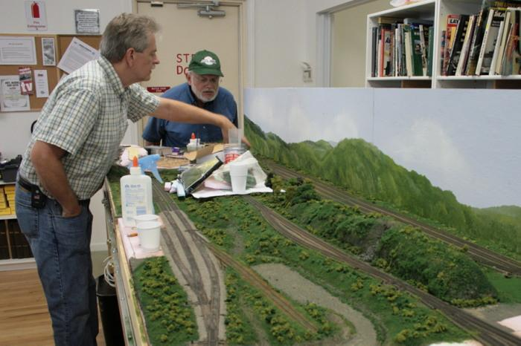

KAMRI Web Site – Bruce McElhoe, Web Site Moderator
There are a number of fun things happening this month. Note the following train items coming up:

- The 2010 NTRAK National Show will be held in Danville, Virginia, September 24–26.

Be sure to check the web site calendar for additional information and links. As always please remember that our web site forum is to communicate ideas, share information, sell, buy, trade, and any other events train related.

Don’t forget! Our web site address is: www.knoxmodelrailroaders.com.

