The SCOOP
February 2011 Vol. 25, No. 2
The newsletter for the Knoxville Area Model Railroad Club, Inc.
Editor: Jim Schall, phone - 423 369-2955, email - Schallj@highland.net
Website : knoxmodelrailroaders.com

As the second month of this New Year begins we need to take a moment to remember Frank Daniels, a KAMR brother who passed away this month. He will be missed by his family and friends.
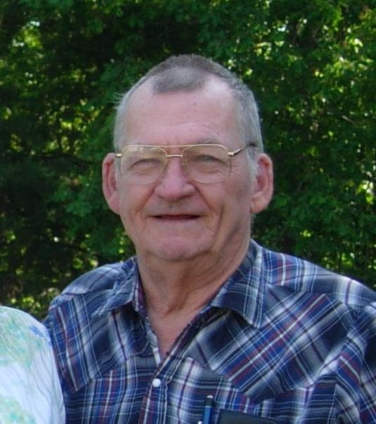

We will be running trains for the International Fest on February 19.

Conductor’s Comments - Bruce McElhoe, President
I’m sure glad we have mostly indoor empires to lose ourselves in. No snow, no sub-freezing temps, and no ice to thwart our enjoyment of a great hobby. I’m also glad that my mental age is hanging around 14 (albeit my physical age just hit 60!). We have a full range of activities this month between Groundhogs day and Presidents Day. I’m sure we are all up to the challenge. So we have open ended orders to proceed down our respective tracks.

KAMRI February event calendar:
- Feb. 6 (1st Sunday): Regular club gathering.
- Feb 19 (Saturday): CMOR International Festival
- Feb 20 (3rd Sunday): Club open house followed by the regular business meeting starting about 4:15.

CMOR will be having a special schools performance on the 18th (Friday) at 10 AM with guest Sean McCollough – Cultures of the World. I’ll check on any needs for KAMRI volunteers.

The Children’s Museum will host their annual International Festival on Saturday, February 19, 2011 from 10 to 4. We will need to have our club open and all division trains running for visitors. As always we need volunteers to come in and help. Please let your division coordinator of your intent and schedule. This is a fun event with a wide variety of foods, crafts, and non-stop entertainment. Saturday’s featured performers will be Coyote Run (great group), with additional entertainment provided by Brandon Beavers and Kukuly Uriarte, Tenpenny Rappers Sword Dancers, Chinese dancers, and classical Indian folk dancers. For more information check our club web site for a full festival schedule.

Note: Parking will be a major pain for this years’ festival with the loss of the back lot. So for all of you volunteers I suggest arriving as early as possible. It’s hoped that the construction of the new front lot will be about completed but with our current weather pattern who knows.

Another Note: Always remember that the last to leave must ensure that all is unplugged, turned off, closed up, shut down, and locked up! This includes soldering irons, lights, blinds, doors, and electrical panels.

Final Note: 2011 DUES ARE DUE. $25 to Bob Strickland asap. You can pay in person now that he has job friendly hours and can be a regular club attendee again. Or, just drop it in the mail.

SPECIAL LIBRARY NEWS - Larry Burkholder
Although Bob Strickland is our Librarian, I would like to mention a task that is underway to make our library more user friendly. Bob and I have been loading information about all the books in our library (not the magazines) into an Internet program called "ConnectCollectorZ". This online program will allow anyone, not just club members, to search our library holdings by title, author, and key words. So far we have entered over 450 books and have probably 100 more to go, about two more weeks of elapsed time. When we have everything entered and have corrected any bugs we will provide instructions on how to use the system.

HO Division – Alex Cameron
The CMOR International Fest is on Saturday, February 19, from 10 AM until 4 PM. We will be running trains all day for that, so come and enjoy the Festival, and help run trains.
Here are the dates for February, 2011. Regular club Sunday meeting on the first Sunday, February 6 will be an operating session (for those not watching football). The third Sunday, February 20 will be a run session, since it is still the regular open house for CMOR. We will start about 1:00. There will be Saturday work sessions on February 12 and 26. Thursday work sessions will be on February 3, 12, 17, and 24 starting at 9:30.
We did operate in January with a small crew. It went fairly smoothly, but only about two thirds of the trains were run. The third Sunday open house was well attended, with a number of people showing up to run trains and we had quite a few visitors also. Dick B collected all the available hoppers on the layout and pulled them behind his N&W class A. I think he had 56 cars that were a mixture of 70 ton and 55 ton hoppers. It made an impressive sight. We will continue to operate on the first Sunday, and run on the third Sunday.
Work session attendance has been very poor for January. Most of the work in the last month has been devoted to maintenance although we have managed to make a little progress. The Lloyd layout has been having control system problems, and all of those have not yet been resolved.
We have managed to ‘band aid’ one long time annoyance. Trains frequently short out on the old code 100 Atlas switches in the staging yard. By studying the problem carefully, and by the application of some masking tape, we have managed to prevent those shorts, and trains will now run into and out of the staging yard without a problem.
Also, we have managed to get 2 more tracks operational in the engine terminal. One for the coal supply track for the coaling tower, and the second is one of the ready tracks that lead to the turntable. We have an idea for a temporary turntable that will at least allow engines to be turned.
We have not made any further progress on the completed a section of bench work using plywood I-beams, and so have not made any spline roadbed yet because manpower has not been available.
Curt and I are still operating on Tuesday AM, and frequently have been having others join us.
Remember to bring locomotives and controllers for the operating session (which will be February 6), and for the run session which is on the third Sunday, February 20, and for the International Fest on February 19.
N/Z-Scale Activities - Larry Burkholder, N/Z coordinator
Work continues on the Traveling Layout. A target of April 1st is set for completion to meet a request for display at a Tellico Village retirement center. This is not just an N-scale project. Anyone who wants to help should Bruce or I know to find out what still needs to be done.

All the materials are ready and the positioning has been defined to start the reworking of the number one main on the N scale layout to enhance "operating". In addition to removing most of the existing track, additional sidings and industries will be identified, built, and installed.

Nothing new with Z scale.

Large Scale Rails – Lance McCold
This month, the large scale division has been making plans for a toy train layout featuring Lionel with American Flyer and lots of action accessories. The concept is to appeal to children and older people who had Lionel or Flyer trains when they were young. The plans are still evolving, but the current concept is that it would occupy the large scale space, but would be designed to travel to shows, very much as the HO and N layouts used to do.
The layout design committee is meeting most Wednesday nights. There is quite a lot more planning to do, but the committee has good momentum.
The G-gauge contingent of the division has recognized that they have the opportunity to build a much more interesting operating layout in the garden and have begun discussions of possible changes.
Next month we plan to continue our current efforts.
In the Garden – Ken Klipple
Due to the weather, it has been a slow month in the garden with little time to run trains. But on the inside we have been making progress toward improving the storage of the trains and buildings. Shelf storage space in the closet has been increased about 50%, and a couple of extra large totes have been added to hold the Southern Lightweight Passenger Cars donated by Dr. Downey. We are waiting on warmer weather to work on expanding the storage in the caboose.

Also in anticipation of warmer weather we have begun planning for rebuilding the tunnels and reworking the waterfall. This work will require a lot of manual labor to move and reset the rocks and soil. We are also planning to add additional sidings to the White and Yellow loops and contemplating a crossover between the Red and White loops. Addition of these track features will allow for a little operation on the layout especially for those with RC and DCC equipment.

KAMRI Web Site – Bruce McElhoe, Web Site Moderator
Be sure to post any items of interest or train shows that might interest others. Or just e-mail any items you would like posted to me at: hmcelhoe@aol.com

